SQL to PySpark Phase 1 – Simple Foundation Pack
Starter PySpark Code
customers = spark.createDataFrame([
(1, "Ravi", "Hyderabad", 25),
(2, "Sita", "Chennai", 32),
(3, "Arun", "Hyderabad", 28)
], ["customer_id", "customer_name", "city", "age"])

- Show all customers
customers.show()
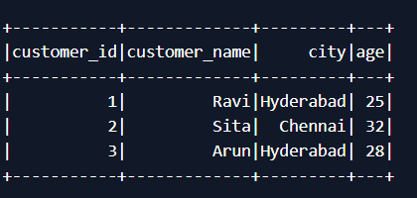

- Show customers from Chennai
customers.filter(customers.city=="Chennai").show()
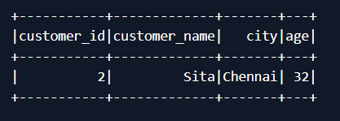

- Show customers with age > 25
customers.filter(customers.age>25).show()
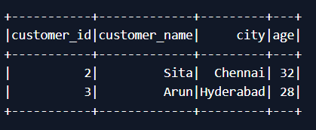

- Show only customer_name and city
customers.select("customer_name","city").show()
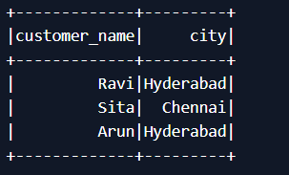
- Count customers city-wise
customers.groupby("city").count().show()

